We like this star for the logo on HOME PAGE. Doesn’t have to be this exact color, but we like the nautical star in rustic earth tones.

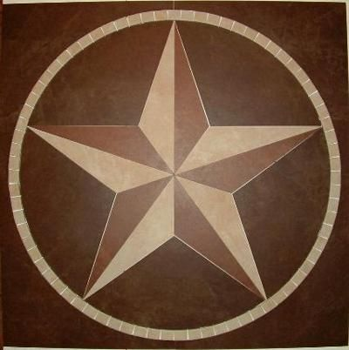

ABOUT US (some of these are redundant):

In 1998, the principals of 3 local agencies came together to form K & S Group, Inc. The goal was to form an agency group that would enable its members to improve the services offered to our clients, provide better market accessibility to our producers, gain efficiencies and cost reduction within the agencies, and satisfy the needs of our carriers. To date, including Consolidated Insurance Partners, the K & S Group membership has grown to 16 Texas agencies.

As a member of K & S Group, Inc., we hold contracts with most national insurance companies as well as the top regional carriers. This gives us options with which to design a program to meet our client’s insurance needs.

We represent clients from a wide spectrum of industries including heavy construction, transportation, artisan contractors, manufacturers, distributors, energy, property owners, and the small business owner, with the construction industry being our largest industry segment.

Today, Consolidated Insurance Partners, K & S Insurance Group, and our affiliated agencies write over $300 million in annual premiums.

Consolidated Insurance Partners offers collectively hundreds of years of experience and knowledge required to deliver industry specific coverage solutions to meet an insureds needs.

We represent a chosen group of financially-sound, reputable insurance & surety companies, and we place your business with the company offering the best coverage and at the same time being conscious of pricing.

We are a full-service agency serving individuals, families, and businesses based in and outside of Texas.

We like this Texas outline(with cities inside). Possibly put a sizable dot in Dallas and Argyle to reflect office locations on CONTACT PAGE.

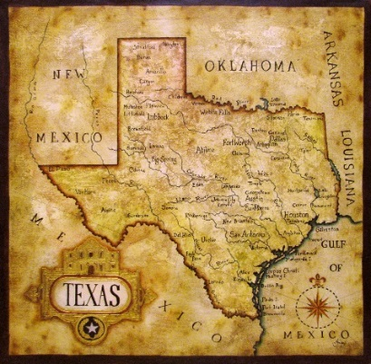

**1) Dallas**

**12201 Merit Dr #220**

**Dallas, TX 75234**

**214-691-5721 phone**

**214-691-4961 fax**

**2) Argyle**

**124 Old Town Blvd North #200**

**Argyle, TX 76226**

**940-464-7100 phone**

**940-464-7105 fax**

We also like these options (or something similar) to go on the RESOURCES PAGE. Include on the resources page insurance glossary terms. Also include insurance and surety diagram. Use only 1 pic, please.



ALSO INCLUDE THIS DIAGRAM ON **RESOURCE PAGE**. MORE TO ADD TO PAGE SHORTLY.

[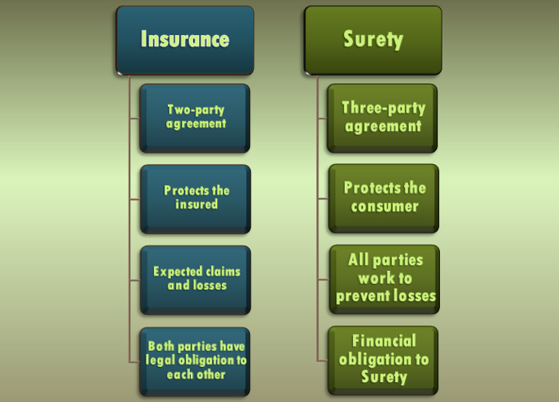](http://www.google.com/url?sa=i&rct=j&q=&esrc=s&source=images&cd=&cad=rja&uact=8&ved=0ahUKEwjxor7DxPrMAhVM7yYKHfsXDJMQjRwIBw&url=http://www.jwsuretybonds.com/blog/insurers-guide-private-investigators&bvm=bv.122676328,d.eWE&psig=AFQjCNHo9tzEv2YO0K2t2QvJ9tyH3HpYWg&ust=1464448113223266)

**MARKETS (incl logos)**

|  |
| --- |
| Bituminous |
| C N A Ins |
| Cincinnati Insurance |
| EMC |
| Great American |
| Hanover |
| Hartford |
| Liberty Mutual |
| MetLife |
| Mid-Continent |
| Nationwide |
| Philadelphia Ins. |
| Progressive |
| Safeco Insurance |
| Suretec |
| Surety 2000 |
| Texas Mutual |
| Travelers |
| Union Standard |
| Utica National |
| Zurich |

SAMPLE HOME PAGE WE LIKE.

[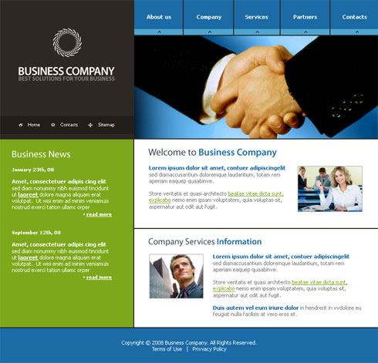](http://www.google.com/url?sa=i&rct=j&q=&esrc=s&source=images&cd=&cad=rja&uact=8&ved=0ahUKEwjk-Y6jh9DMAhWMKCYKHddaArsQjRwIBw&url=http://www.lancashireembroidery.co.uk/business-home-page/&bvm=bv.121421273,d.eWE&psig=AFQjCNEfhmGdma6mlOycRBOQXuYztosDqQ&ust=1462988330186036)

Pics for rotating banner on home page

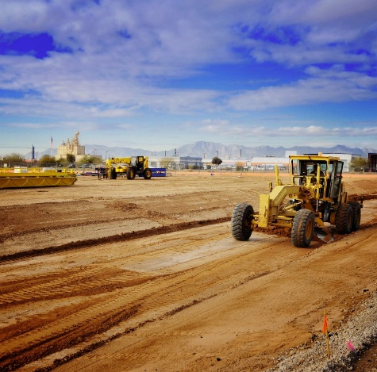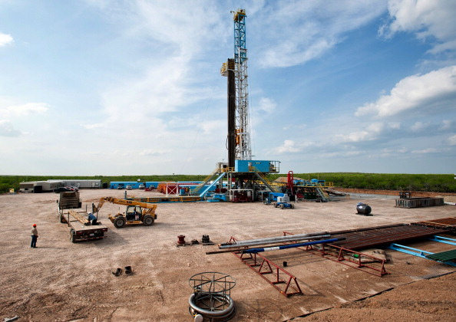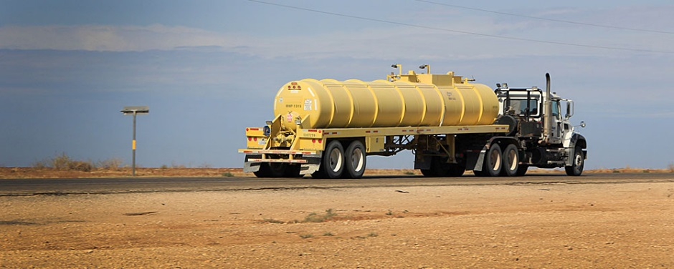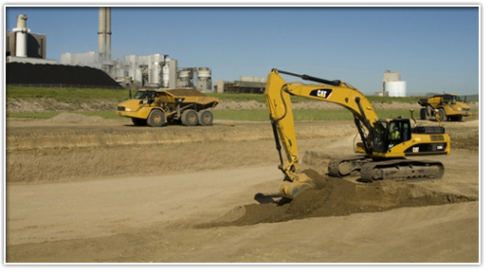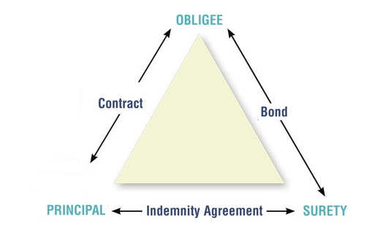

**SERVICES PAGE**:

We provide a range of coverage tailored for your personal & commercial insurance, farm & ranch and all bonding needs.

 [](http://www.google.com/url?sa=i&rct=j&q=&esrc=s&source=images&cd=&cad=rja&uact=8&ved=0ahUKEwjTo87qyvrMAhUBzSYKHTa9D8gQjRwIBw&url=http://www.wisegeek.com/how-can-i-reduce-gas-consumption.htm&bvm=bv.122676328,d.eWE&psig=AFQjCNE3eeJhjHbxfeieIa1tsSa3naDULA&ust=1464449813673641) 